**Experiment-1.2**

**Student Name: Modassir Imran UID: 20BCS9727**

**Branch: BE-CSE Section/Group: 606 /B**

**Semester: 6th  Date of Performance: 15/02/2023**

**Subject Name: IOT Lab Subject Code: 20CSP-358**

**Aim:** Identification of different sensors used in IoT applications.

**Objectives:**

1. To study hardwares related to IoT.

2. to understand and identify different sensors used in IoT.

**Sensors:**

The sensors are defined as a machine, module, or a device that detect changes in the environment. The sensors transfer those changes to the electronic devices in the form of a signal. A sensor and electronic devices always work together. The output signal is easily readable by humans. Nowadays, Sensors are used in daily lives. For example, controlling the brightness of the lamp by touching its base, etc. The use of sensors is expanding with new technologies.  
  
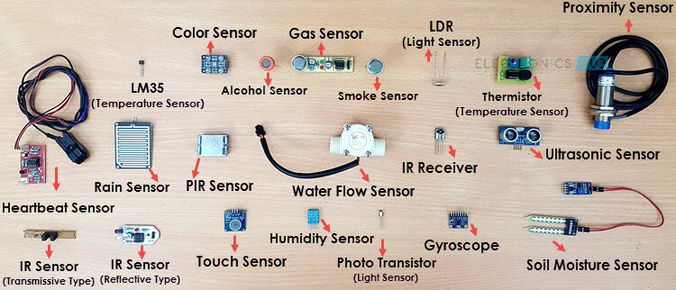

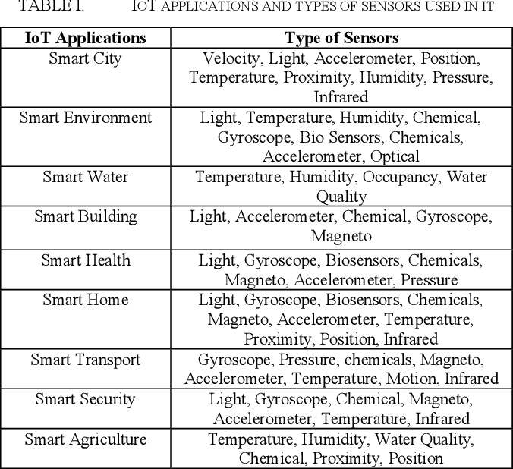

1. Temperature sensors

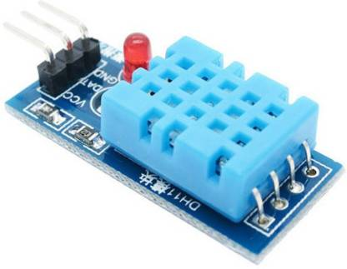

By definition, “A device, used to measure amount of heat energy that allows to detect a physical change in temperature from a particular source and converts the data for a device or user, is known as a Temperature Sensor.”

Followed are some sub-categories of Temp Sensors:

* **Thermocouples:** These are voltage devices that indicate temperature measuring with a change in voltage. As temperature goes up, the output voltage of the thermocouple rises.
* **Resistor temperature detectors (RTD):** The resistance of the device is directly proportional to the temperature, increase in a positive direction when the temperature rises resistance going up.
* **Thermistors:** It is a temperature sensitive resistor that changes its physical resistance with the change in temperature.
* **IC (Semiconductor):** They are linear devices where the conductivity of the semiconductor increases linearly and it takes advantage of the variable resistance properties of semiconductor materials. It can provide a direct temperature reading in digital form, especially at low temperatures.
* **Infrared sensors:** It detects temperature by intercepting a portion of emitted infrared energy of the object or substance, and sensing its intensity, can be used to measure temperature of solids and liquids only, not possible to use it on gases because of their transparent nature.

2. Proximity sensor

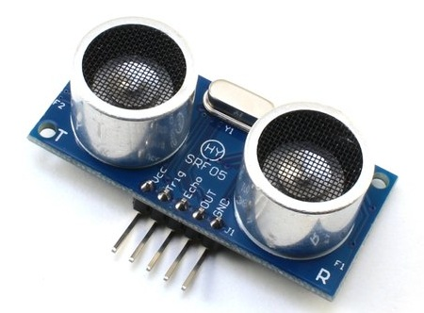

A device that detects the presence or absence of a nearby object, or properties of that object, and converts it into signal which can be easily read by user or a simple electronic instrument without getting in contact with them.

Following are some of the Proximity Sensors sub-categorised:

3. Pressure sensor

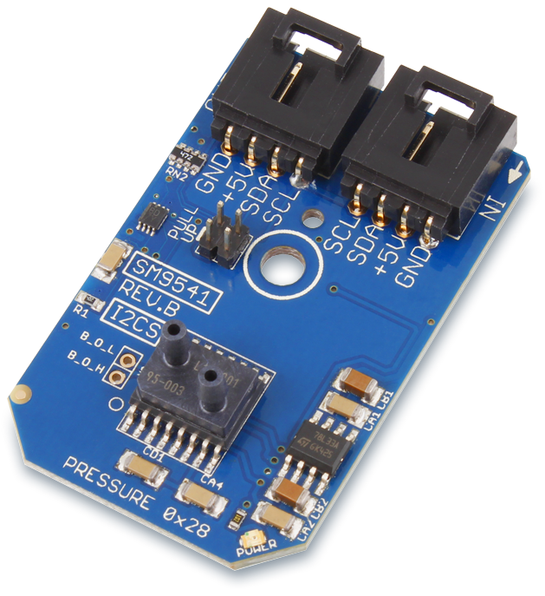

A pressure sensor is a device that senses pressure and converts it into an electric signal. Here, the amount depends upon the level of pressure applied.

4. Water Quality Sensor

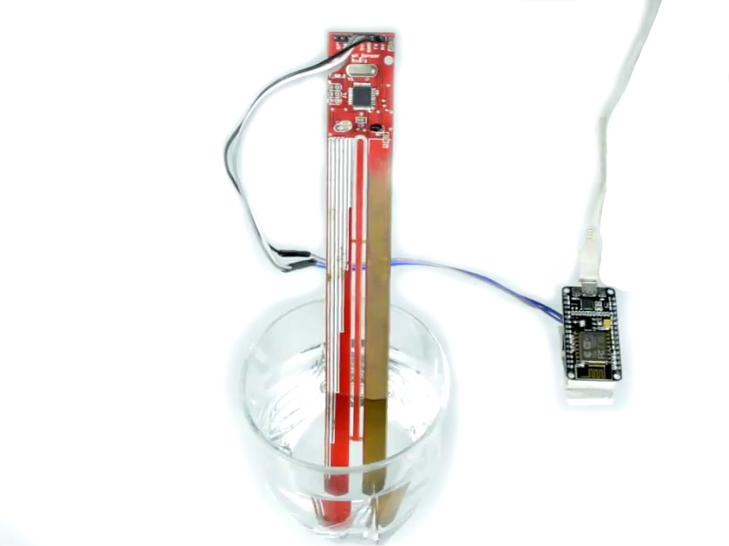

Water quality sensors are used to detect the water quality and Ion monitoring primarily in water distribution systems.

Water is practically used everywhere. These sensors play an important role as they monitor the quality of water for different purposes. They are used in a variety of industries.

Following is a list of the most common kind of water sensors in use:

* **Chlorine Residual Sensor:** It measures chlorine residual (i.e. free chlorine, monochloramine & total chlorine) in water and most widely used as disinfectant because of its efficiency.
* **Total Organic Carbon Sensor:** TOC sensor is used to measure organic element in water.
* **Turbidity Sensor:** Turbidity sensors measure suspended solids in water, typically it is used in river and stream gaging, wastewater and effluent measurement.
* **Conductivity Sensor:** Conductivity measurements are carried out in industrial processes primarily to obtain information on total ionic concentrations (i.e. dissolved compounds) in water solutions.

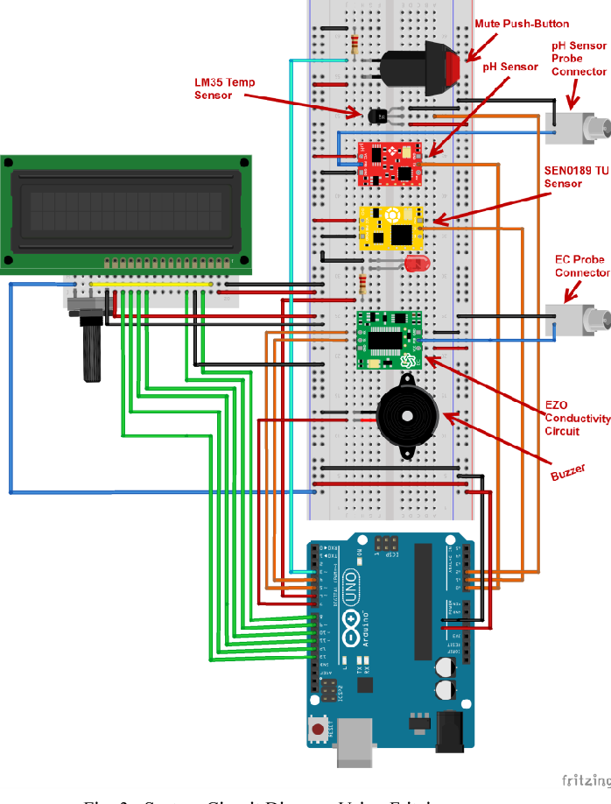

5. Chemical sensor

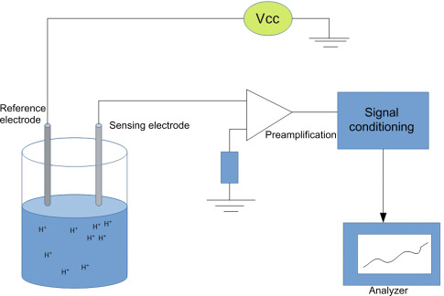

Chemical sensors are applied in a number of different industries. Their goal is to indicate changes in liquid or to find out air chemical changes. They play an important role in bigger cities, where it is necessary to track changes and protect the population.

Following are most common kind of chemical sensors in use:

* Chemical field-effect transistor
* Chemiresistor
* Electrochemical gas sensor
* Fluorescent chloride sensor
* Hydrogen sulfide sensor
* Nondispersive infrared sensor

6. Gas sensor

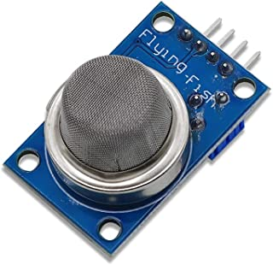

Gas sensors are similar to the chemical ones, but are specifically used to monitor changes of the air quality and detect the presence of various gases. Like chemical sensors, they are used in numerous industries such as manufacturing, agriculture etc.

Following are some common Gas sensors:

* Carbon dioxide sensor
* Breathalyzer
* Carbon monoxide detector
* Catalytic bead sensor
* Hydrogen sensor
* Air pollution sensor
* Nitrogen oxide sensor
* Oxygen sensor
* Ozone monitor
* Electrochemical gas sensor
* Gas detector
* Hygrometer

7. Smoke sensor

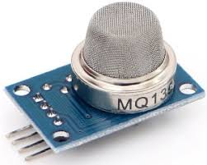

A smoke sensor is a device that senses smoke (airborne particulates & gases), and it’s level.

They have been in use for a long period of time. However, with the development of IoT, they are now even more effective, as they are plugged into a system that immediately notifies the user about any problem that occurs in different industries.

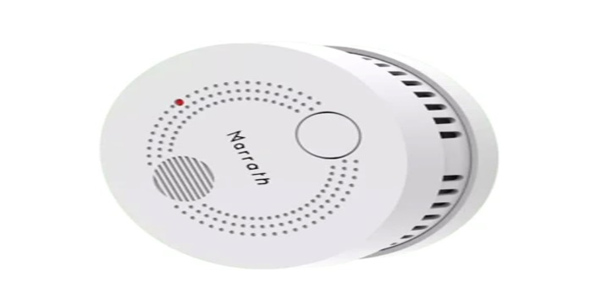

Smoke sensors are extensively used by the manufacturing industry, HVAC, buildings, and accommodation infra to detect fire and gas incidences. This serves to protect people working in dangerous environments, as the whole system is much more effective in comparison to the older ones.

Common Types of Smoke Sensors

Smoke sensors detect the presence of Smoke, Gases and Flame surrounding their field. It can be detected either optically or by the physical process or by the use of both the methods.

* **Optical smoke sensor (Photoelectric):** Optical smoke sensor used the light scatter principle trigger to occupants.
* **Ionization smoke sensor:** Ionization smoke sensor works on the principle of ionization, kind of chemistry to detect molecules causing a trigger alarm.

8. IR sensors

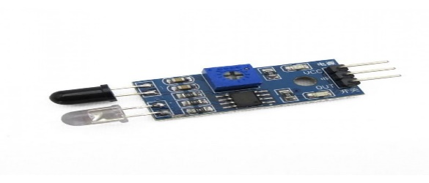

An infrared sensor is a sensor that is used to sense certain characteristics of its surroundings by either emitting or detecting infrared radiation. It is also capable of measuring the heat being emitted by objects.

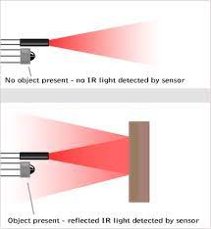

9. Level sensors

A sensor which is used to determine the level or amount of fluids, liquids or other substances that flow in an open or closed system is called Level sensor.

There are two basic level measurement types:

* **Point level sensors:** Point level sensors usually detect the particular specific level and respond to the user if the sensing object is above or below that level. It is integrated into single device to get an alarm or trigger
* **Continuous level Sensor:** Continuous level sensors measure liquid or dry material levels within a specified range and provide outputs which continuously indicate the level. The best example of it is fuel level display in the vehicle.

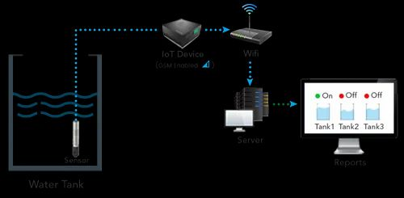

10. Image sensors

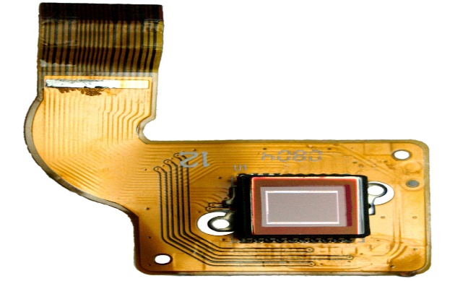

Image sensors are instruments which are used to convert optical images into electronic signals for displaying or storing files electronically.

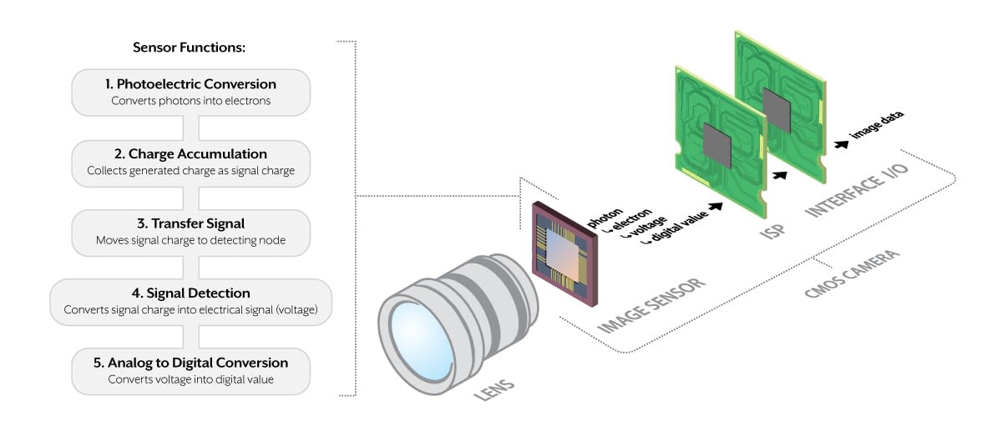

An average consumer would think that this is a regular camera, but even though this is not far from the truth, image sensors are connected to a wide range of different devices, making their functionality much better.

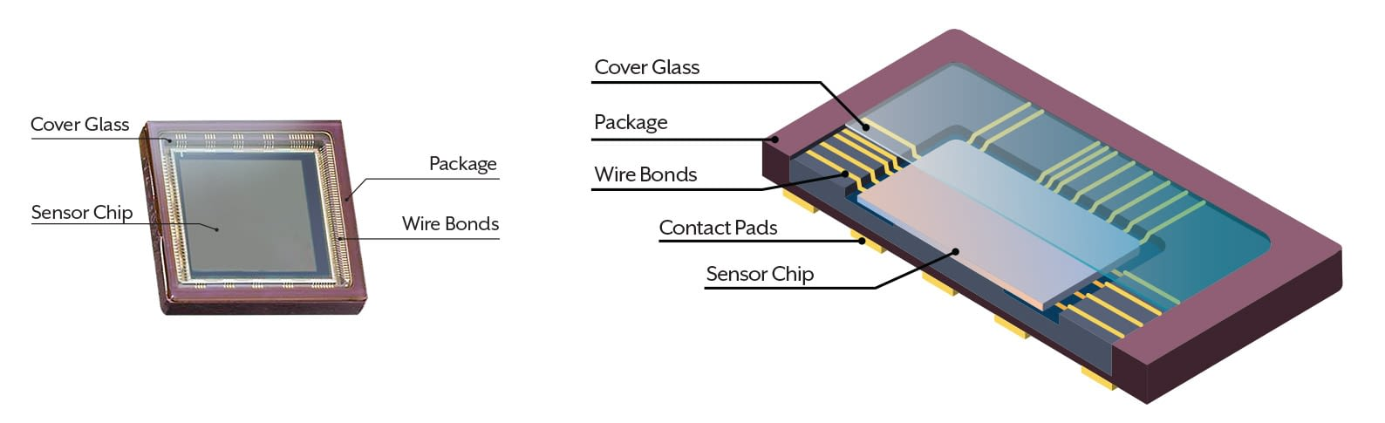

11. Motion detection sensors

A motion detector is an electronic device which is used to detect the physical movement (motion) in a given area and it transforms motion into an electric signal; motion of any object or motion of human beings

